**Practice Case 07 - Business Case 01**

**By : Herdis Haerusalam**

**Date : 14 November 2019**

*Assume you are a product manager/data scientist (or anyone who has capability to make a change) in a Startup. The startup name is BukaToko and they are one of largest marketplace. Their main vision is to help small businesses to get wider market and buyers can buy product safely. This company also creates trusted payment ecosystem for both seller and buyer. Event though they have a complex security to protect transaction of sellers and buyers, several frauds have inflicted loss to all parties, especially BukaToko themselves. Cashback fraud, Fake “Cheap” Product, Transaction outside platform, Fake shipping receipt, and so forth are the problems that harmful and need to be solved soon. You, as the one who dedicated to stop these problems, need to make your own team to cooperate and solve these.*

**Questions :**

1. Which problem you prioritize the most? And Why? (Choose one and focus on that topic)

2. Which business components that will be your team to solve the problem? Why?

3. How you define and identify the problem?

4. What is your synthesized solution?

**Answers :**

1. So, There are four problems in BukaToko which are ***Cashback fraud, Fake “Cheap” Product, Transaction outside platform, Fake shipping receipt****.* To tackle those problems we have to analyze one by one.

* ***Cashback fraud***, each cashback will affect to our payment ecosystem trustworthiness and financial loss, let say we have affiliation with one of trusted e-wallet, each of transaction using their payment, we have to give them commission let say 1% each of transaction. If we have total volume of transaction of 1 trillion rupiah each month, we have to pay 10 Million rupiah, if we have cashback fraud rate in 0.1 % , it could be 1 Million rupiah loss. This problem will have direct impact to our financial and trustworthiness (payment partners, buyers and seller).
* ***Fake “Cheap” Product***, affect on market perspective and trustworthiness. The fake “cheap” product will affected to our brand perspective to our market. This problem can be handle by making some marketing campaign (such as money back guarantee and so on) to bounce back .
* ***Transaction outside platform***, Trust has important roles in the business transactions. In wider understanding, business transactions will occur when each parties has trust in their business relationships. The transaction outside the platform it means can decreasing our vision values.
* ***Fake shipping receipt***, affect to our trustworthiness to buyers, this problem can be tackle by improving our system in clarifying the shipping has done.

Based on analysis we can use eisenhower matrix to making decision what problems to focus on.

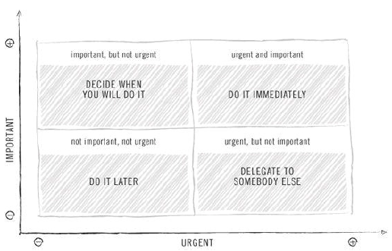

1. The topic that we focused on is “**cashback fraud**”, so we will break down into each business components.

* **Marketing** (marketing and R&D), basically marketing will have to maintain to e-wallet partner to discuss about the problems, marketing (public relation) also will tackle the problem to public by maintaining our brand perspective on market.

Research and Development, will focused on developing technology that can detect this kind of fraud “cashback fraud” by using their historical behavior to prevent further same kind of fraud or another fraud.

* **Finance**, will focused on to maintaining relationship with e-wallet partner (along with marketing) to handle such as profit loss.
* **Operation (special fraud teams)**, will act based on finding R&D on fraud finding, if we find some suspicious seller or buyers will have strict rules.

1. **Define (problem statement):**

Our recent “cashback fraud” making bad financial loss and reducing trustworthiness to buyers/seller impact to BukaToko

**Identifying:**

* Bad identifying selected eligible customer
* Not quite good Buyers/Seller verification scheme
  + Improving or change the verification scheme

1. **The Synthesis:**

**“bad fraud prevent tool”**

creating technology by R&D that could prevent this kind of unpredictable fraud scheme.